
COLLEGE OF SCIENCE
AND TECHNOLOGY

DEPARTMENT OF PHYSICS

FIRST TRIMESTER EXAMINATIONS – ACADEMIC YEAR 2020-2021

DEPARTMENT: Physics

LEVEL OF STUDY: Year 1

STUDY GROUP: CSE, CS, IT, IS (Huye) & CS (Musanze)
MODULE CODE: PHY1163
MODULE NAME: Physics for Engineers I
MODULE WEIGHTING: 10 Credits
DATE: ................

DURATION: 3 hours
MAXIMUM MARKS = 50
INSTRUCTIONS

- This paper contains 5 questions to be answered to in 2 Sections: Section A and Section B.
- Section A is compulsory; you must answer to all the questions.
- Section B allows a choice; select any 2 questions from the 3 questions given and answer to them.
- Write both your Registration and your Examination Numbers on the Examination Booklets provided.
- Write all your answers only in the examination booklet provided.
- Do not write on this question paper.
- Start each question on a fresh page.
- No unauthorized material is allowed in the examination room.
- Use the following information if needed:
Acceleration due to the gravity$g=9.8m/s^{2}$

SECTION A: COMPULSORY QUESTIONS / 20 marks
Question 1/10 marks
- The air bubble formed by explosion inside water performs oscillations with time period T which depends on pressure (p), density (ρ) and on energy due to explosion (E). Establish the relation between T, p, E and ρ./2marks
- What are the assumptions made for a simple analysis of a free-falling motion?/2marks
- In the freely falling motion a ball is thrown vertically upward. What are its velocity and acceleration when it reaches its maximum altitude? What is its acceleration just before it strikes the ground?/2marks
- What is the difference between a scalar quantity and a vector quantity? /2 marks
- Differentiate between a steady flow and unsteady flow. /2 marks

Question 2 / 10 marks
- State the work-energy theorem, and give its mathematical expression /2 marks
- If the velocity of a particle ( of mass m) is tripled, by what factor is its kinetic energy changed?/1 mark
- Using the relationship between the conservative force and the potential energy function, find the conservative forces for the following potential energy functions: /2marks
- A 5.00­kg ball, moving to the right at a velocity of +2.00 m/s on a frictionless table, collides head­on with a stationary 7.50­kg ball. Find the final velocities of the balls if the collision is
- Elastic; /2 marks
- Completely (Perfectly) inelastic; /2 marks
- How much energy was lost in the inelastic collision? /1 mark

SECTION B: FROM THIS SECTION, CHOOSE ONLY TWO QUESTIONS / 30 marks
Question 3 /15 marks
- A stone is thrown from the top of a building with an initial velocity of 20.0 m/s straight upward, at an initial height of 50.0 m above the ground. The stone just misses the edge of the roof on its way down. Determine:
- The time needed for the stone to reach its maximum height; /2 marks
- The maximum height; /2 marks
- The time needed for the stone to return to the height from which it was thrown and the velocity of the stone at that instant; /2 marks
- The time needed for the stone to reach the ground; /2 marks
- The velocity and position of the stone at t = 5.00 s. /2 marks

- A metal rod that is 4.00 m long and 0.50 cm² in cross-sectional area is found to stretch 0.20 cm under a tension of 5000 N. What is Young’s modulus for this metal?/ 2.5 marks
- Calculate the elastic energy stored up in a wire originally 5 meter long and 10⁻³ m in diameter which has been stretched by 3×10⁻⁴m due to a load of 10 kg. /2.5 marks

Question 3 /15 marks
A harmonic wave is characterized by the equation of propagation:
$$u\left(t\right)=A sin⁡(ωt+φ)$$
- Name all the components of the equation:$u, A, ω, and φ$, /2 marks
- The acceleration of this wave can be given by $\frac{d^{2}u}{{dt}^{2}}$. Compute the accelation and show that it is proprtional to $ω^{2}u$, /3 marks
- If $ω=20π rad/s$, deduce the frequency and period of the wave, /2 marks
- And if the wave is moving at a phase velocity of 2 m/s, what is its the wavelength? /2 marks
- Show that an object of mass m mounted on a spring moving freely on a frictionless horizontal plane, the period $T=2π{(\frac{m}{k})}^{1/2}$, where m is the mass and K is the spring constant. /6 marks

Question 4 /15 marks
- Give two ways and examples in which a force is exerted on an object without doing any work on the object. /4 marks
- A man cleaning a frictionless floor pulls a vacuum cleaner with a force F of magnitude 50 N at an angle of 30° with the horizontal. /5 marks
- Draw a labeled free body diagram showing all the forces that act on the vacuum cleaner.
- What is the magnitude of the work done by the weight of the vacuum cleaner? Explain briefly.
- Calculate the work done by the force F on the vacuum cleaner as the vacuum cleaner is displaced 3 m to the right.

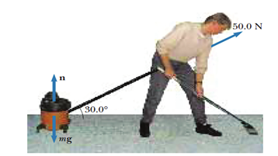

- Given that the moment of inertia of a rod rotating around an axis through one end perpendicular to its length is$I=\frac{Ml^{2}}{3}$. Using the parallel axis theorem prove that the moment of inertia of this rod is $I=\frac{Ml^{2}}{12}$ when it rotates about an axis through its center perpendicular to its length. /3 marks

- The stress-train graph from a solid is shown in the figure below. Indicate what OA, A, B, C, D and E stand for in the graph /3marks
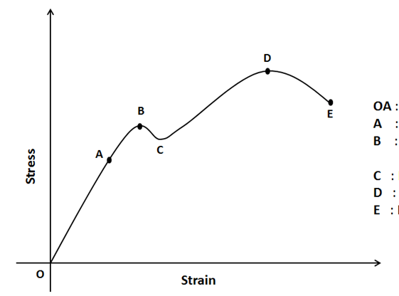

End of Questions

